Game engine creation

Super Mario Bros clone

Table of Contents

Glossary 1

Keywords 1

Introduction 2

What Went Well 3

Results 4

Conclusion 5

Future Work/Further Reading 6

Bibliography 7

Appendix 8

# Instructions

The Game I have created is a Super Mario Bros clone. The objective of the game is to reach the end flag without dying and collect as many coins as you can for a good score. You have to players so make sure to keep them close because if one dies you can carry on as the other! You only have one life per character and if you die you go back to the beginning of the game so be careful!

The controls are as follows;

Mario;

Left arrow – move left

Right arrow – move right

Up arrow – jump

Luigi;

A key – move left

D key – move right

W key – jump

General;

SPACE – used in menus when prompted to

Q – quits the game no matter what

The game plays very similar to the original Super Mario Bros with just a few things missing. Although there are enemies, they do not attack you as I did not Implement it in time. Coins get you 50 points and reaching the end flag gets you 1000, these are the two ways to get score.

# Screenshots of Game Screens

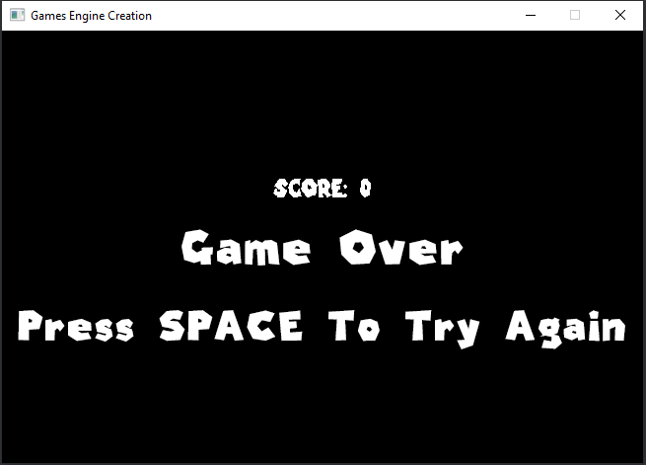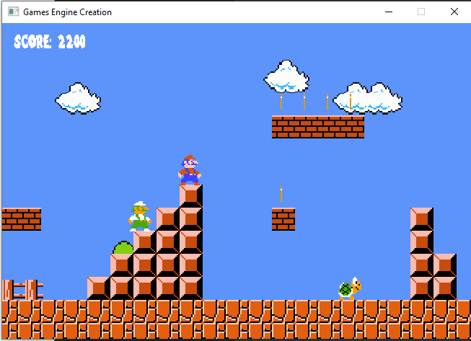

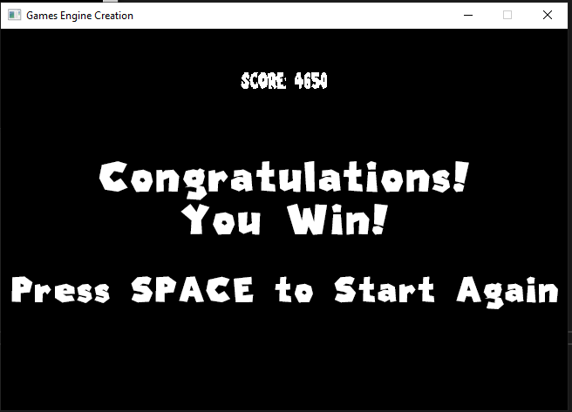

# Test Plan

|  |  |  |  |
| --- | --- | --- | --- |
| Test No | Test Description | Expected Outcome | Actual Outcome |
| 1 | Check Mario controls | Mario controls work as expected | Mario controls work as expected |
| 2 | Check Luigi controls | Luigi controls work as expected | Luigi controls work as expected |
| 3 | Check the game runs correctly | Game should load onto the start screen | Game loads onto start screen |
| 4 | Check level one works by pressing space on start screen | Game should start level one | Game loads level one |
| 5 | Check level two works by touching the flag | It should load level two after the flag is touched | Level two loads after flag is touched |
| 6 | Check coins can be collected by walking into them | Coins should pick up and add to score | Coins get picked up and added to score |
| 7 | Check win condition of touching the flag in level two | The win screen should show after the flag is touched | Win screen shows after flag is touched |
| 8 | Check death screen works after both characters die | After both characters die you should see the death screen | The death screen shows when you die |
| 9 | Collisions work when walking into walls for Koopas and Characters | Koopas should flip when hitting a wall and characters should stop | Koopas flip, characters stop |
| 10 | Sound works across all levels and screens | Sound should play on both levels and the game over screen and win screen | The sounds play |
| 11 | Sound works for characters | Mario/Luigi makes a jump noise and a coin collected noise | The sounds play |
| 12 | Check if the camera scrolls with the player | Camera should scroll when the player moves to the right | Camera scrolls |
|  |  |  |  |